WELCOME TO
LEAFIELD ATHLETIC FOOTBALL CLUB

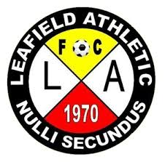 “SECOND TO NONE”

PLAYERS INFORMATION PACK

OUR GROUND DETAILS
TYTHE BARN LANE
Our U7 to U12 Teams are based at Tythe Barn Lane, B90 1PH
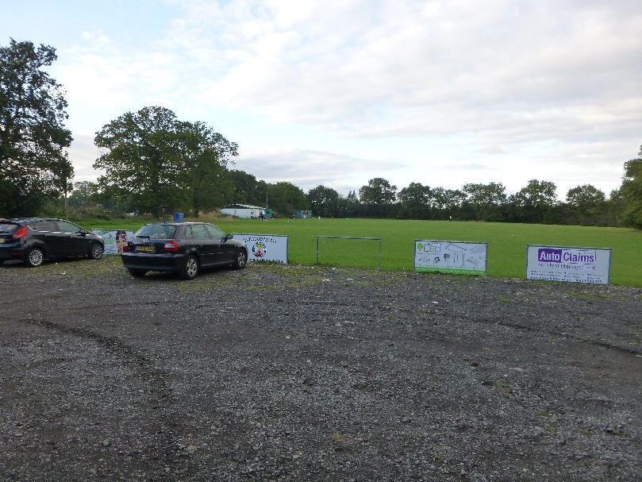

RUMBUSH LANE
Our U13 to U18 Teams together with our Adult and Over 35s (Vets) Teams are based at Rumbush Lane, B94 5NA
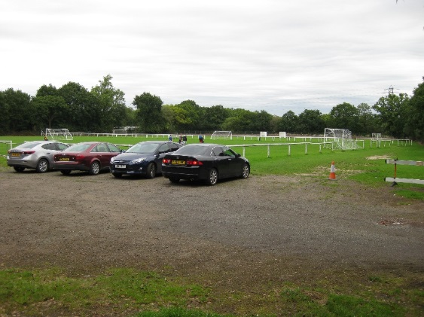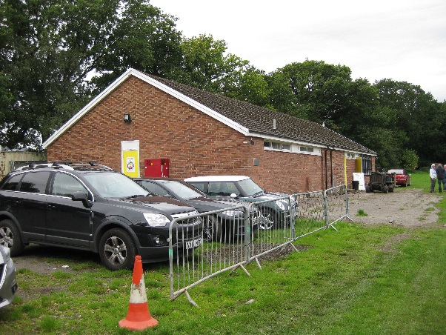
There is car parking available at both of our grounds although at peak times these do become very full. We ask that all parents, guardians and other spectators park considerately to ensure access is possible to and from the ground and that access it available to emergency vehicles if required.

OUR CLUB
Leafield Athletic Football Club was formed in 1970 and is one of the oldest clubs in the local area. As such the Club is very proud that we helped and continue to do so many kids who enjoy playing football.
All our teams and the children who want to play football for them would not exist without the people who take on the role of managers, coaches, club secretaries and treasurers and of course not forgetting those parents, guardians who bring the children to the matches throughout the season. Leafield Athletic thank you all for making Leafield Athletic FC the great Club that it is.
Finally, a warm welcome to all our Players this season, LAFC wish you a great footballing season.

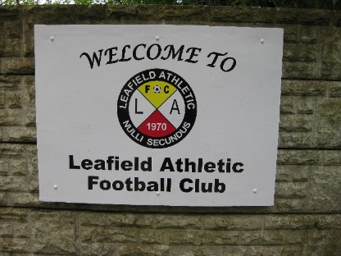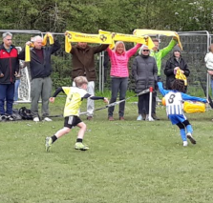
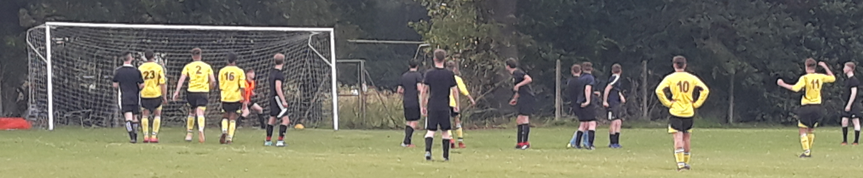
Leafield Athletic Club Officers
CHAIRMAN | Darren Swann | 07971 566004
VICE CHAIRMAN | Steve Clarke | 07772 732069
SECRETARY | Nigel Livingstone | 07900 497940
TREASURER | Nigel Livingstone | 07900 497940
Clubhouse Manager/Groundsman | Richard Pittaway | 07732 875597
Child Welfare Officer | Jarrod Marsland/Nigel Livingstone | 07905 484622/07900 497940

Code of Conduct for LAFC Players
As a Club LAFC align themselves with rules and guidance issued by the Football Association and as such Club Officers, Managers, Coaches all have a responsibility to promote high standards of behaviour in the game.
As a LAFC player, you have a big part to play and therefore LAFC ask every player to follow our Respect Code of Conduct.
As a Player, I will:
- Not wear jewellery during training or matches.
- At all times wear shin pads during all training sessions and matches
- Bring a water bottle filled with water/simple juice to every training session and matches throughout the season.
- Make every effort to develop and improve my own ability in terms of skill, technique, tactics and stamina.
- Give maximum effort and set a positive example to other team members
- Inform or ask their parent/guardian to contact the team Manager in good time if they are not available for a match or training session.
- Not use inappropriate language in training sessions or matches.
- Not intentionally damage pitch surfaces by digging up/gouging/etc.
- Not to intentionally cause damage to LAFC equipment, eg goals, respect barriers, corner flags, etc by for example swinging on goals, kicking corner flags.
- Respect requests by LAFC Clubhouse Manager/LAFC Officers when using LAFC Clubhouse facilities.
When playing football, I will:
- Always play to the best of my ability
- Play fairly – I won’t cheat, complain or waste time
- Respect my team-mates, the other team, the referee and/or my Manager/Coach
- Play by the rules, as directed by the referee
- Shake hands with the other team and referee at the end of the game
- Listen and respond to what my team Manager/Coach tells me
- Talk to someone I trust or the club welfare officer if I’m unhappy about anything at my club.
I understand that if I do not follow the LAFC Code, any/all of the following actions may be taken by LAFC, Football League(eg CWYFL, MJPL ,Birmingham County FA or The FA).

I may:
- Be required to apologise to my team-mates, the other team, referee, lineman team manager or team coach.
- Receive a formal warning from the Team Manager or LAFC Club Secretary.
- Be dropped or substituted.
- Be suspended from training/match day.
- Be required to leave the club.

In addition:
- LAFC, Football League( eg CWYFL, MJPL), Birmingham County FA or The FA may make my parent or guardian aware of any infringements of the Code of Conduct.
- LAFC could impose a fine and/or suspension against the LAFC player.
- The FA/County FA could impose a fine and/or suspension against me.

As a Player for a Leafield Athletic FC Team, I confirm acceptance of the above LAFC Rules for Players. Note: Parent or Guardian to Sign Form.

Team: Leafield Athletic Under …………………….

Player Name:

.............................................................................................
(Print Name)

Player Signature:

…………………………………………………………………………………………

Parent/Guardian Signature:

………………………………………………………………………………………………………….………………
Return signed form to LAFC Team Manager (scan copy or photograph copy will suffice). LAFC will review player registration if a signed form has not been received from the Player or Parent or Guardian.

