WELCOME TO
LEAFIELD ATHLETIC FOOTBALL CLUB

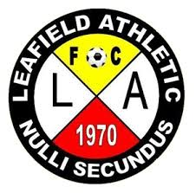 “SECOND TO NONE”

MANAGERS/COACHES INFORMATION PACK

OUR GROUND DETAILS
TYTHE BARN LANE
Our U7 to U12 Teams are based at Tythe Barn Lane, B90 1PH
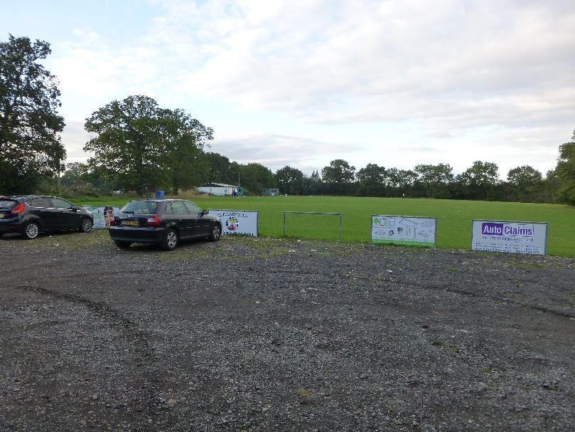

RUMBUSH LANE
Our U13 to U18 Teams together with our Adult and Over 35s (Vets) Teams are based at Rumbush Lane, B94 5NA
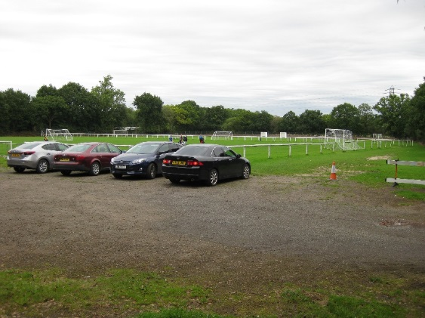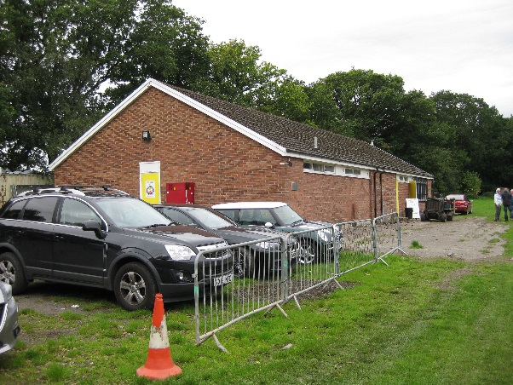

There is car parking available at both of our grounds although at peak times these do become very full. We ask that all parents, guardians and other spectators park considerately to ensure access is possible to and from the ground and that access is available to emergency vehicles if required.

OUR CLUB
Leafield Athletic Football Club was formed in 1970 and is one of the oldest Clubs in the local area. As such the Club is very proud to have helped so many kids to enjoy playing football and continue to do so.

Our junior teams play in the Central Warwickshire Youth Football League which was founded in 1969 to support minor and youth teams, U7-U18 teams.

None of our teams would exist without the people who take on the roles of Club Officers, Managers, Coaches, First Aiders, Team Secretaries and Treasurers and of course not forgetting those Parents/ Guardians who bring the children to training and matches throughout the season. Leafield Athletic thank you all for making Leafield Athletic FC the great Club that it is.

Finally, a warm welcome to all our new Managers and their teams this season, LAFC wish you and your players a great footballing season.

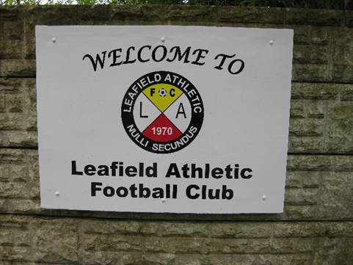
CHAIRMAN | Darren Swann | 07971 566004
VICE CHAIRMAN | Steve Clarke | 07772 732069
SECRETARY | Nigel Livingstone | 07900 497940
TREASURER | Nigel Livingstone | 07900 497940
Clubhouse Manager/Groundsman | Richard Pittaway | 07732 875597
Child Welfare Officer | Jarrod Marsland/Nigel Livingstone | 07905 484622/07900 497940

CLUB RULES
Code of Conduct for LAFC Managers & Coaches
- Managers/Coaches must respect the rights, dignity and worth of each and every person and treat each equally within the context of the sport.

- Managers/Coaches must place the well-being and safety of each player above all other considerations, including the development of performance.

- Managers/Coaches must be aware of any health issues their players may have.

- Managers/Coaches must adhere to all guidelines laid down by governing bodies.

- Managers/Coaches must develop an appropriate working relationship with each player based on mutual trust and respect.

- Managers/Coaches must not exert undue influence to obtain personal benefit or reward.

- Managers/Coaches must encourage and guide players to accept responsibility for their own behaviour and performance.

- Managers/Coaches must ensure that the activities they direct, or advocate are appropriate for the age, maturity, experience and ability of the players.

- Managers/Coaches should, at the outset, clarify with the players (and, where appropriate, parent) exactly what is expected of them and also what they are entitled to expect from their coach.

- Managers/Coaches must co-operate fully with other specialists (e.g. other coaches, officials, doctors) in the best interests of the player.

- Managers/Coaches must always promote the positive aspects of the sport (e.g. fair play) and never condone violations of the Laws of the Game, behaviour contrary to the spirit of the Laws of the Game or relevant rules and regulations or the use of prohibited substances or techniques.

- Managers/Coaches must consistently display high standards of behaviour and appearance.

- Managers/Coaches must not use or tolerate inappropriate language.

- Managers/Coaches must comply with LAFC Disciplinary Procedures and Guidance (2022).

- Managers/Coaches must comply with LAFC Information issued by Club Officers.

- Managers/Coaches must comply with any Club Health Directives (eg COVID -19 Requirements) issued.

- Managers/Coaches to complete required Football Association Courses/Qualifications required for the position. Guidance for these will be given by LAFC Club Secretary.

LAFC Team Fees and Fees

The Manager agrees to collect Players Fees and ensure payment of Team Fees and LAFC Player Registration Fees required by LAFC for the 2022/2023 season.

Team Player Fines

Fines incurred by team player from LAFC, Birmingham FA, Central Warwickshire Youth Football League or Midland Football League to be paid for by Parent or Guardian to LAFC Team Manager or LAFC Club Secretary within 2 weeks of request by LAFC or Team Manager.

As a Manager of a Leafield Athletic FC Team, I confirm acceptance of the above LAFC Rules for LAFC Team Managers.

Team: Leafield Athletic Under …………………….

Manager Name:

.............................................................................................
(Print Name)

Manager Signature:

…………………………………………………………………………………………
Return signed form to LAFC Secretary (scan copy or photograph copy will suffice).

